A Real-time Research Project / Societal Related Project
Report on

<Title of the Project>
Submitted in Partial fulfillment of requirements for B.Tech II Year II Semester course

By

<SAMREEN FATIMA> <23BD1A1256>
<VEDASREE RAMARAM> <23BD1A1265>
<HIRAL JAIN> <23BD1A1222>
<MANASA JALLURI> <23BD1A1223>
<T.CH.SRI CHARAN SAI> <23BD1A12C4>

Under the guidance of

Ms./Mr./Dr. TULASI
<Designation>, <Department>
& Ms./Mr./Dr. HARISMITA
<Designation>, <Department>



KESHAV MEMORIAL INSTITUTE OF TECHNOLOGY
(AN AUTONOMOUS INSTITUTION)
Accredited by NBA & NAAC, Approved by AICTE, Affiliated to JNTUH.

Narayanaguda, Hyderabad, Telangana-29
2024-25



KESHAV MEMORIAL INSTITUTE OF TECHNOLOGY
(AN AUTONOMOUS INSTITUTION)
Accredited by NBA & NAAC, Approved by AICTE, Affiliated to JNTUH

Narayanaguda, Hyderabad, Telangana-29

CERTIFICATE


This is to certify that this is a bonafide record of the project report titled “CHAT-BOT” which is being presented as the Real-time Research Project / Societal Related Project report by

- SAMREEN FATIMA 23BD1A1256
- VEDASREE RAMARAM 23BD1A1265
- HIRAL JAIN 23BD1A1222
- MANASA JALLURI 23BD1A1223
5.T.CH.SRI CHARAN SAI 23BD1A12C4

In partial fulfillment for the II Year II Semester Course RTRP in KMIT affiliated to the Jawaharlal Nehru Technological University Hyderabad, Hyderabad

Mentors
(Ms/Mr/Dr. XXXX Program Coordinator
(Ms/Mr/Dr. XXXX) (Mr Shailesh Gangakhedkar)

Submitted for Final Project Review held on ____________________________

Vision & Mission of KMIT

Vision of KMIT

  - To be the fountainhead in producing highly skilled, globally competent engineers.
  - Producing quality graduates trained in the latest software technologies and related tools and striving to make India a world leader in software products and services.

Mission of KMIT

  - To provide a learning environment that inculcates problem solving skills, professional, ethical responsibilities, lifelong learning through multi modal platforms and prepares students to become successful professionals.
  - To establish an industry institute Interaction to make students ready for the industry.
  - To provide exposure to students on the latest hardware and software tools.
  - To promote research-based projects/activities in the emerging areas of technology convergence.
  - To encourage and enable students to not merely seek jobs from the industry but also to create new enterprises.
  - To induce a spirit of nationalism which will enable the student to develop, understand India's challenges and to encourage them to develop effective solutions.
  - To support the faculty to accelerate their learning curve to deliver excellent service to students.

PROGRAM OUTCOMES (POs)

PO1. Engineering Knowledge: Apply the knowledge of mathematics, science, engineering fundamentals, and an engineering specialization to the solution of complex engineering problems.

PO2. Problem Analysis: Identify formulate, review research literature, and analyze complex engineering problems reaching substantiated conclusions using first principles of mathematics, natural sciences, and engineering sciences


PO3. Design/Development of solutions: Design solutions for complex engineering problems and design system components or processes that meet the specified needs with appropriate consideration for the public health and safety, and the cultural, societal, and environmental considerations.

PO4. Conduct Investigations of Complex problems: Use research-based knowledge and research methods including design of experiments, analysis and interpretation of data, and synthesis of the information to provide valid conclusions.

PO5. Modern Tool Usage: Create select, and, apply appropriate techniques, resources, and modern engineering and IT tools including prediction and modeling to complex engineering activities with an understanding of the limitations.

PO6. The Engineer and Society: Apply reasoning informed by contextual knowledge to societal, health, safety. Legal und cultural issues and the consequent responsibilities relevant to professional engineering practice.

PO7. Environment and Sustainability: Understand the impact of the professional engineering solutions in societal and environmental contexts and demonstrate the knowledge of, and need for sustainable development.

PO8. Ethics: Apply ethical principles and commit to professional ethics and responsibilities and norms of the engineering practice.

PO9. Individual and Team Work: Function effectively as an individual, and as a member or leader in diverse teams and in multidisciplinary settings.

PO10. Communication: Communicate effectively on complex engineering activities with the engineering community and with society at large, such as, being able to comprehend and write effective reports and design documentation, make effective presentations, and give and receive clear instructions.

PO11. Project Management and Finance: Demonstrate knowledge and understanding of the engineering and management principles and apply these to one's own work, as a member and leader in a team, to manage projects and in multidisciplinary environments.


PO12. Life-Long Learning: Recognize the need for, and have the preparation and ability to engage in independent and life-long learning in the broadest context of technological change.

PROJECT OUTCOMES

P1: Write Your Project Outcomes Here
P2: Write Your Project Outcomes Here
P3: Write Your Project Outcomes Here
P4: Write Your Project Outcomes Here

MAPPING PROJECT OUTCOMES WITH PROGRAM OUTCOMES

PO | PO1 | PO2 | PO3 | PO4 | PO5 | PO6 | PO7 | PO8 | PO9 | PO10 | PO11 | PO12
P1
P2
P3
P4

L – LOW M –MEDIUM H– HIGH

DECLARATION

We hereby declare that the results embodied in the dissertation entitled “<Title>” has been carried out by us together during the academic year 2024-25 as a partial fulfillment of the B.Tech II Year II Semester Course “Real-time Research Project / Societal Related Project”. We have not submitted this report to any other Course/College.



Student Name Rollno.

<SAMREEN FATIMA> <23BD1A1256>
<VEDASREE RAMARAM> <23BD1A1265>
<HIRAL JAIN> <23BD1A1222>
<MANASA JALLURI> <23BD1A1223>
<T.CH.SRI CHARAN SAI> <23BD1A12C4>

ACKNOWLEDGEMENT

We take this opportunity to thank all the people who have rendered their full support to our project work. We render our thanks to Dr. B L Malleswari, Principal who encouraged us to do the Project.

We are grateful to Mr. Neil Gogte, Founder & Director and Mr. S. Nitin, Director, for facilitating all the amenities required for carrying out this project.

We express our sincere gratitude to Ms. Deepa Ganu, Director Academic for providing an excellent environment in the college.

We are also thankful to Mr.Shailesh Gangakhedkar, Real-Time Research Project Program Coordinator for providing us with time to make this project a success within the given schedule.

We are also thankful to our Project Mentor Ms. Tulasi, for her valuable guidance and encouragement given to us throughout the project work.

We would like to thank the entire KMIT faculty, who helped us directly and indirectly in the completion of the project.

We sincerely thank our friends and family for their constant motivation during the project work.

Student Name Roll no.

< SAMREEN FATIMA> <23BD1A1256>
<VEDASREE RAMARAM> <23BD1A1265>
<HIRAL JAIN> <23BD1A1222>
<MANASA JALLURI> <23BD1A1223>
<T.CH.SRI CHARAN SAI> <23BD1A12C4>

ABSTRACT

In this project, we present the design and implementation of a college-specific chat-bot system tailored for KMIT. The proposed solution integrates a user-friendly frontend with a powerful backend powered by Natural Language Processing (NLP) and Retrieval-Augmented Generation (RAG). The chat-bot is capable of answering queries related to college information, events, academics, departments, and more, by leveraging a pre-trained language model and a knowledge base built from the official college website. The system includes both software components — a React-based interface and a server powered by Open-Router API key and cloud services for storage and deployment. This chat-bot aims to provide instant, accurate responses to users without the need for manual search, improving information accessibility, reducing repetitive administrative tasks, and enhancing the overall digital experience within the institution. The system is scalable, supports real-time updates, and can be extended for additional features such as multilingual support.

LIST OF FIGURES

S.No | Name of Screenshot | Page No.
1.
2.
3.
4.
5.

CONTENTS

DESCRIPTION PAGE CHAPTER - 1 1
  - INTRODUCTION 2-4
    - Purpose of the project 2
    - Problem with Existing Systems 2
    - Proposed System 3
    - Scope of the Project 3
    - Architecture Diagram 4
CHAPTER – 2 5
  - LITERATURE SURVEY 6-7
CHAPTER - 3 8
  - SOFTWARE REQUIREMENT SPECIFICATION 9-12
    - Introduction to SRS 9
    - Role of SRS 9
    - Requirements Specification Document 10
    - Functional Requirements 10
    - Non-Functional Requirements 11
    - Performance Requirements 11
    - Software Requirements 11
    - Hardware Requirements 12
CHAPTER – 4 13
  - SYSTEM DESIGN 14-30
    - Introduction to UML 14
    - UML Diagrams 15
      - Use Case Diagram 15
      - Sequence Diagram 18
      - State Chart Diagram 19
      - Deployment Diagram 20
    - TECHNOLOGIES USED 21
CHAPTER – 5 32
  - IMPLEMENTATION 33-42
    - Setting up connections with Raspberry PI 33q
    - Coding the logic 35
    - Connecting the dashboard 40
    - Screenshots 42
    - UI Screenshots 43
CHAPTER – 6 44
  - SOFTWARE TESTING 45-51
    - Introduction 45
      - Testing Objectives 45
      - Testing Strategies 45
      - System Evaluation 48
      - Testing New System 49
    - Test Cases 50
CONCLUSION 52
FUTURE ENHANCEMENTS 53
REFERENCES 54
BIBLIOGRAPHY 55

CHAPTER-1

INTRODUCTION

INTRODUCTION
In the era of digital transformation, providing instant and accurate information is crucial for academic institutions. Students, parents, and staff often seek quick answers regarding courses, faculty, events, timetables, and administrative processes. Traditional systems involving manual search or staff interaction are time-consuming and inefficient. This project aims to address these issues by developing an intelligent chat-bot system for KMIT College, capable of understanding user queries and delivering relevant information instantly using Natural Language Processing and Retrieval-Augmented Generation (RAG).

1.2 Problem with Existing Systems (2)
Currently, students rely on scattered resources such as college websites, notice boards, emails, or staff consultations to get information. This approach is inefficient due to:
- Lack of centralized information access.
- Delays in response time.
- Overburdening administrative staff.
- Poor user experience due to manual navigation.
These limitations create confusion, especially for new students or visitors seeking quick information.

1.1 Purpose of the Project (2)
The primary purpose of the KMIT College Chat-bot project is to design and develop a smart, conversational AI system that serves as a digital assistant for the college community. It is intended to simplify and streamline the way students, faculty, and visitors access institutional information. By leveraging Natural Language Processing (NLP) and machine learning, the chatbot will understand and respond to a wide variety of queries related to academics, campus facilities, faculty details, placement activities, examination schedules, admission procedures, and upcoming events.
This chatbot will be seamlessly integrated into the official KMIT college website, offering an intuitive chat interface that users can interact with in real time. The system will be trained on curated data sourced from the college’s website and internal documentation to ensure accurate and contextually relevant responses.
By automating the information delivery process, the project aims to:
- Reduce the dependency on administrative staff for routine queries.
- Enhance the user experience by eliminating the need for manual searching through web pages or physical notice boards.
- Ensure 24/7 availability so users can access information at any time, without delays.
- Create a scalable platform that can be further enhanced with voice input/output, multi-language support, or academic integrations like student portals in future versions.
This initiative not only supports digital transformation within the institution but also reflects a step toward adopting AI-driven solutions in the education sector.
.

1.3 Proposed System (3)
The proposed system is an AI-based chat-bot built using a modular architecture involving a front-end interface, middleware API, and cloud-based storage. It will:
- Be embedded within the KMIT website for accessibility.
- Use data scraped and organized from official sources like the KMIT website, brochures, and manuals.
- Process user queries via the Open-Router API with LLaMA models, ensuring coherent and context-aware responses.
- Retrieve data from a Cloud Database (supabase) rather than vector databases.
- Support text-based interactions with fast and scalable performance.
This system ensures reliable answers with minimal latency, aligned with current trends in server-less and API-based deployments.

1.4 Scope of the Project (3)
This chat-bot aims to:
- Answer college-related FAQs: courses, departments, admissions, placements, facilities, events, and more.
- Be accessible from any device through the college website.
- Maintain a secure, scalable backend using a cloud database.
- Eliminate the need for direct human intervention in common queries.
- Be extensible for future features like:
  - Admin panel for knowledge base updates.
  - Multilingual support.
  - Voice-enabled chat functionality.
  - Integration with student login portals for personalized responses.

Architecture…….

CHAPTER-2

2. LITERATURE SURVEY
In recent years, AI-based chatbots have evolved significantly and are being widely adopted across domains such as education, healthcare, finance, and customer support. This chapter presents an overview of existing chatbot technologies, their applications in academic settings, and how recent advancements in natural language processing (NLP) have made intelligent college assistants both feasible and effective.

2.1 Traditional Chatbots
Early chatbot systems were rule-based and operated using hardcoded decision trees or simple pattern-matching logic. Examples include ELIZA (1966) and ALICE (1995), which used scripts to simulate conversation. These systems lacked contextual understanding and failed to handle diverse or unexpected queries. In academic institutions, such bots could only provide pre-programmed answers to a narrow set of questions, making them insufficient for real-world usage.

2.2 NLP-Powered Chatbots
With the emergence of NLP techniques and deep learning, chatbots have become far more capable. Libraries such as spaCy, NLTK, and Transformers revolutionized text analysis. Chatbots today can understand context, identify user intent, and dynamically generate responses. They can be trained on domain-specific data, such as institutional FAQs or web content, to provide more accurate and relevant answers.
Many universities have adopted NLP chatbots to streamline communication. For example:
- MIT’s FinAid Chatbot answers questions related to student finance.
- Georgia State University reported a reduction in summer melt by 22% after deploying a chatbot for student support.

2.3 LLM-Based Chatbots
The latest generation of chatbots leverages Large Language Models (LLMs) like GPT, LLaMA, and Claude to generate human-like text. These models are pre-trained on vast corpora of text data and can respond intelligently to natural language queries with little or no task-specific training. Unlike traditional systems, LLMs can handle ambiguity, context-switching, and complex questions.
LLaMA, developed by Meta and now accessible via OpenRouter API, is a lightweight and efficient LLM capable of generating accurate and contextually appropriate responses. It is ideal for academic chatbot deployments due to its balance of performance and resource usage.

2.4 Cloud-Based Chatbot Integration
Modern chatbot systems are typically hosted on cloud infrastructure for scalability and reliability. Using Firebase or MongoDB Atlas, developers can securely store structured knowledge bases that support fast data access. Cloud deployment also ensures:
- 24/7 availability
- Real-time updates to the knowledge base
- Easier integration with authentication services
This cloud-based architecture is essential for delivering responsive and scalable chatbot experiences to a wide audience, such as students and faculty.

2.5 Gaps in Existing Systems
While many institutions use chatbots, most still suffer from:
- Limited domain-specific customization
- Inability to understand regional context or institutional nuances
- Lack of integration with dynamic college data
- No support for modern LLMs or scalable APIs
Hence, there is a need for a custom-built, LLaMA-powered chatbot tailored specifically to KMIT’s academic ecosystem, using OpenRouter API for AI and cloud databases for structured data storage.

CHAPTER-3

3.1 Introduction to Software Requirement Specification (SRS)
The Software Requirement Specification (SRS) document plays a crucial role in the software development lifecycle by clearly defining the expected functionalities, features, and constraints of the KMIT College Chatbot project. This chatbot is designed to provide an intelligent, interactive interface for students, faculty, and staff to quickly access academic information and campus resources.
The primary objective of the SRS is to act as a formal agreement between stakeholders—such as college administrators, students, and the development team—ensuring a mutual understanding of what the chatbot system should deliver. It serves as a comprehensive guideline that describes both functional requirements (specific behaviors and capabilities the chatbot must exhibit) and non-functional requirements (performance, usability, reliability, and security).
By outlining the system specifications in a clear and detailed manner, the SRS reduces ambiguity and helps prevent miscommunication during development. It also serves as a foundation for system design, implementation, testing, and future maintenance. This document covers the integration of the LLaMA language model via the OpenRouter API for natural language processing, and the use of a cloud-hosted database for storing college-specific data securely and efficiently.

3.2 Role of the Software Requirement Specification (SRS)
The SRS document plays multiple key roles in the success of the chatbot project:
- Blueprint for Development and Testing: It provides a structured framework that guides developers in building the chatbot according to predefined requirements and ensures that testing teams can validate the system’s functionality and performance against these benchmarks.
- Defines Project Scope and Boundaries: The SRS specifies what the chatbot will and will not do, preventing scope creep and keeping the project focused on delivering agreed features within time and resource constraints.
- Ensures Stakeholder Alignment: By clearly documenting requirements, it fosters consensus among project stakeholders—college management, end users, and developers—ensuring everyone shares a common vision of the chatbot’s goals and capabilities.
- Identifies Functional and Non-Functional Requirements: It details the expected functionalities, such as query handling, response generation, and database interaction, alongside quality attributes like response time, security, usability, and scalability.
- Supports Future Enhancements and Maintenance: As the college’s needs evolve, the SRS serves as a reference document to evaluate new features, facilitate troubleshooting, and guide iterative improvements while maintaining system integrity.
In summary, the SRS acts as a critical communication tool and contractual baseline that drives the successful implementation of the KMIT College Chatbot project, helping ensure that the final product meets user expectations and operational goals.

3.3 Requirements Specification Document
The Requirements Specification Document comprehensively outlines all the essential requirements needed to build, deploy, and maintain the KMIT College Chatbot system. This document categorizes the requirements into several key areas: functional requirements, non-functional requirements, performance needs, software specifications, and hardware specifications.
It acts as a reference point throughout the development process, ensuring that every component of the chatbot—from the user interface and natural language processing to backend data management and hosting—is carefully planned and documented. This structured approach helps in minimizing misunderstandings, managing stakeholder expectations, and guiding the development team in delivering a system that meets the college’s specific needs.
By dividing requirements into logical sections, the specification ensures that both the technical and operational aspects are addressed. For example, while functional requirements focus on what the chatbot should do—such as responding to queries or retrieving information—non-functional requirements emphasize how well the system performs, including speed, reliability, and security. This clarity is vital for designing a solution that is both effective and user-friendly.

3.4 Functional Requirements
The functional requirements specify the core functionalities that the chatbot must implement to effectively serve the KMIT college community. These requirements directly address the capabilities the system must have to meet user expectations and deliver relevant, timely information.
- User Query Interface: The chatbot will provide a web-based interactive interface accessible through any modern browser. Users (students, faculty, staff) can type or speak queries related to academic and administrative information.
- Natural Language Processing with LLaMA: The chatbot will integrate with the OpenRouter API to utilize the LLaMA large language model. This allows it to understand user inputs in natural language, interpret intent, and generate coherent, context-aware responses.
- Cloud Database Integration: To provide accurate and updated information, the chatbot will connect to a cloud-hosted database such as Firebase Firestore or MongoDB Atlas. This database will store structured data including course syllabi, faculty details, exam timetables, admission procedures, and placement records.
- Context-Aware Response Generation: The chatbot must intelligently combine LLaMA-generated text with factual data retrieved from the cloud database, ensuring that responses are not only fluent but also accurate and relevant to KMIT’s specific environment.
- Real-Time Interaction: The system should process and respond to queries within a minimal delay, targeting an average response time of 2–3 seconds to maintain a seamless user experience.
- Query Types and Use Cases: The chatbot will handle diverse query categories, such as:
  - Detailed course descriptions and syllabus
  - Faculty member profiles and office hours
  - Examination schedules and important deadlines
  - Admission eligibility and application status
  - Placement opportunities and company visit updates
- Fallback Handling: For queries outside its knowledge base or unclear inputs, the chatbot will provide polite fallback responses guiding the user to rephrase or seek help from human support.

3.5 Non-Functional Requirements (Page 11)
- Usability: User interface should be simple, clean, and accessible to all users including non-technical individuals.
- Reliability: Should maintain high uptime with minimal errors in chatbot responses.
- Scalability: Capable of serving multiple users simultaneously without degradation in performance.
- Security: Secure API calls and protected database access. No sensitive data is stored locally.
- Maintainability: Codebase should be modular for easy updates and fixes..

3.6 Performance Requirements
To deliver a seamless user experience, the chatbot should adhere to the following performance standards:
- The chatbot must respond to user queries within 2–3 seconds on average, ensuring real-time interaction.
- The system should handle at least 100 concurrent users without crashing or slowing down.
- Monthly downtime must not exceed 1%, and error logs must be regularly reviewed to maintain service reliability.
- When knowledge base data is updated through the admin panel, changes should reflect in user responses within 5 minutes of deployment.
These benchmarks help maintain a high-performance, responsive system capable of serving a growing college user base.

3.7 Software Requirements
To build and deploy the chatbot efficiently, the following technologies and tools will be used:
- Frontend:
  - React.js for building the dynamic user interface.
  - Tailwind CSS or Material UI for styling, ensuring responsiveness and consistency across devices.
- Backend:
  - Node.js with Express.js will serve as the core server handling API requests and routing logic.
  - Axios or Fetch API will manage HTTP requests between the frontend and external APIs like OpenRouter.
- AI Integration:
  - The chatbot will use OpenRouter API to access LLaMA models, enabling advanced natural language understanding and response generation.
- Database:
  - A cloud-based database called supabase will store all structured data (faculty info, timetables, admission info, etc.) securely and scalably.
- Other Tools:
  - Git/GitHub for version control and team collaboration.
  - Postman for API testing and debugging.
  - Vercel, Render for hosting and continuous deployment.
This technology stack is chosen to ensure rapid development, ease of maintenance, and long-term scalability for the chatbot system.

CHAPTER-4

4.1 Introduction to UML
Unified Modeling Language (UML) is a standardized modeling language widely used in software engineering to visually represent the design and structure of a system. It helps developers and stakeholders understand system architecture before implementation. UML offers a range of diagram types that illustrate both the static and dynamic aspects of the system. In this project, UML diagrams are used to depict the design of the KMIT Chatbot system, focusing on its interactions, behavior, and deployment.

4.2 UML Diagrams
UML diagrams are essential tools to model the architecture and functionality of the system. The chatbot design is described using the following diagrams:
4.2.1 Use Case Diagram
The Use Case Diagram illustrates the different functionalities provided by the chatbot system from the end-user’s perspective. It identifies key actors like students and faculty, and maps out the services they can access through the chatbot.
Actors:
Student
Faculty
Admin (for future extensions)
Use Cases:
Ask academic-related queries
Ask admission-related questions
View examination schedule
Access faculty information
Get placement updates

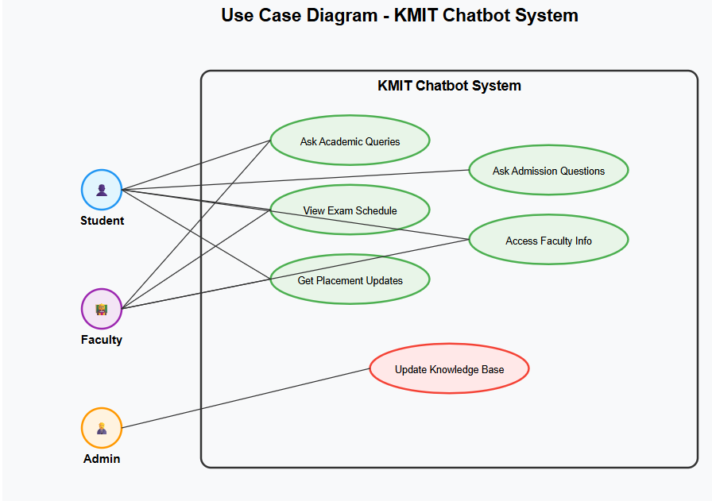

4.2.2 Sequence Diagram
The Sequence Diagram demonstrates the flow of communication between the user and system components. It shows how a query is handled step by step, involving components like the frontend, backend server, NLP model, and the database.
Flow Sequence:
User inputs query via the chatbot interface
Request sent to backend server
Backend interacts with OpenRouter API (LLaMA model)
Backend fetches related data from Supabase
Response is constructed and returned to user
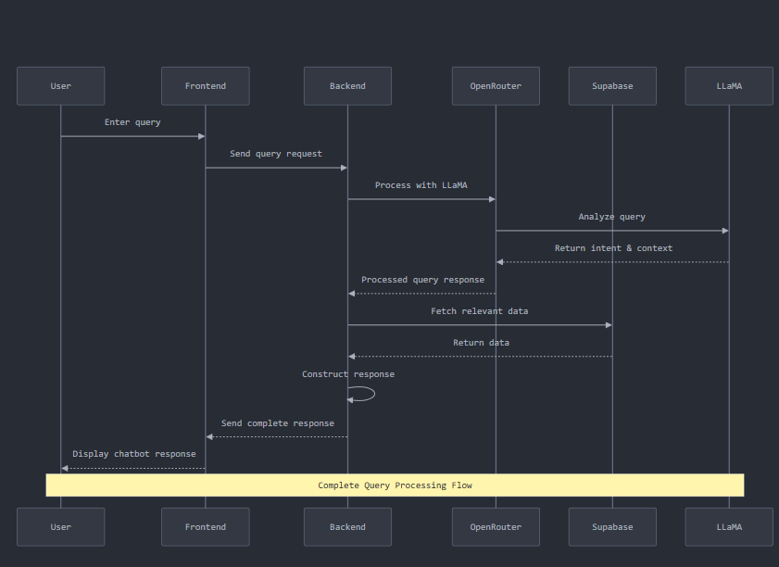

4.2.3 State Chart Diagram
The State Chart Diagram depicts the states the chatbot system transitions through during a typical interaction. It helps in visualizing how the system behaves dynamically.
Typical States:
Idle
Listening
Processing
Fetching Data
Responding
Idle
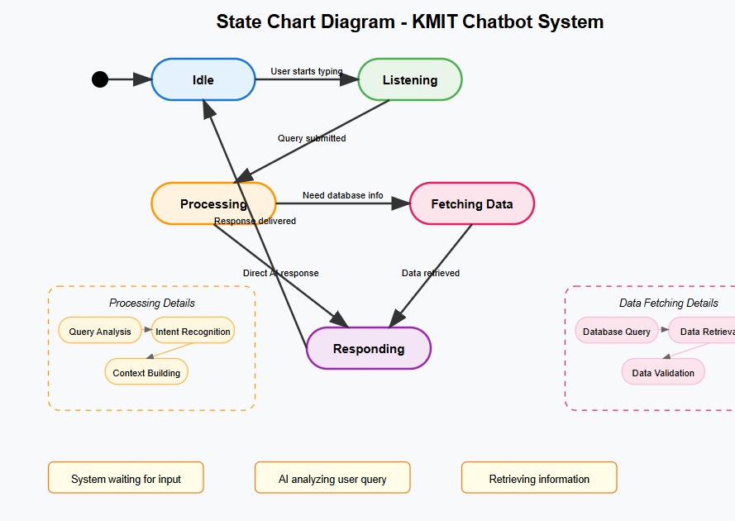

4.2.4 Deployment Diagram
The Deployment Diagram provides a high-level overview of how different components of the chatbot system are deployed in real-time.
Nodes and Components:

Client device (Browser)

Frontend hosted on Vercel

Backend server hosted on Render

OpenRouter API for NLP tasks

Supabase Cloud Database for knowledge storage

4.3 Technologies Used
The following technologies were used for the development and deployment of the chatbot system:

Frontend: React.js, Tailwind CSS

Backend: Node.js with Express.js

AI Integration: OpenRouter API using LLaMA model

Database: Supabase

Deployment: Vercel (Frontend), Render (Backend)

Tools: Git/GitHub (Version Control), Postman (API Testing), draw.io (for UML Diagrams)

CHAPTER-5

5.1Setting up the Scraping Tool
The scraping tool was implemented to extract academic and institutional content from reliable online sources. Using Python libraries such as BeautifulSoup and Requests, the tool fetches structured content and formats it as JSON. It runs at scheduled intervals to ensure updated context is available to the chatbot’s backend.

5.2 Coding the Logic
The backend logic was written in Node.js. It accepts user queries from the frontend, processes them semantically, retrieves matching content from the Supabase database, and sends the response through OpenRouter’s LLaMA model. The final output is sent back to the user via the frontend interface.

5.3 Connecting the Dashboard
A web-based dashboard was built using React.js and Tailwind CSS to monitor the scraping tool and display system status. The dashboard provides logs, scrape history, and manual refresh options. This helps in maintaining system transparency and ensures administrators can track the system’s health and accuracy.

5.4 Screenshots
The following are backend and scraping tool execution screenshots showing logs of scraping activities and API communications.

5.5 UI Screenshots
Below are screenshots of the chatbot interface. The frontend allows users to input queries, view generated responses, and interact through voice or text.

CHAPTER-6

6.1 Introduction
Software testing is an essential phase of the development cycle. It ensures that each component of the system performs as expected. For this chatbot-based academic assistant, testing was conducted to validate functionality, integration, and performance.

6.1.1 Testing Objectives
The primary objectives of testing the chatbot system were:

To verify the accuracy of scraped academic content.

To ensure correct integration of APIs and database.

To validate responsiveness and reliability of the frontend UI.

To ensure the feature mentioned in the SRC are working .

6.1.2 Testing Strategies
The following strategies were used:

Unit Testing: Backend functions and scraper modules were tested individually.

Integration Testing: Ensured smooth operation between the frontend, backend, OpenRouter API, and Supabase.

System Testing: The full chatbot system was tested with real user queries.

Regression Testing: Re-ran tests after updates to ensure old features remained stable.

6.1.3 System Evaluation
The system was evaluated on parameters such as response time, accuracy, and uptime. Real-time usage simulation was done to check system behavior under different load conditions.working of the features have been evaluated . User feedback was also gathered for subjective evaluation.

6.1.4 Testing New System
The chatbot system was tested with a test group of students and faculty members. Sample questions from the academic domain were provided and their responses were recorded. Most responses were highly accurate and matched expectations. Some edge cases led to slightly off-topic replies, which were analyzed and improved.

6.2 Test Cases
Test cases were designed based on common academic queries. Each test case included input (user query), expected output, actual output, and result (pass/fail). Below is a sample:
Test Case 1:

Input: “Who is the Deepa Gaanu?”

Expected Output: “Deepa Gaanu is the academic director of kmit .”

Actual Output: “Deepa Gaanu is the academic director of kmit.”

Result: Pass

Test Case 2:

Input: “What are the department names in kmit?”

Expected Output: “CSE,CSD,AIML,IT are the departments in kmit.”

Actual Output: “CSE,CSD,AIML,IT are the departments in kmit..”

Result: Pass

More test cases are documented in the appendix.

CONCLUSION
The development of the academic assistant chatbot marks a significant step toward automating and simplifying access to institutional information for students and faculty. In a world where timely and accurate information is critical to academic success, this chatbot bridges the gap between users and scattered information sources by offering an intelligent, unified, and accessible solution.
By integrating a web scraping tool, cloud database (Supabase), and OpenRouter’s LLaMA-based generative AI, the system was able to successfully interpret user queries, fetch the most relevant information, and provide human-like responses. The scraping module continuously ensures that the database is populated with the most recent academic content, while the generative model interprets natural language inputs, making the system easy to use for both tech-savvy and non-technical users.
The chatbot supports real-time interaction, handles a wide range of queries (such as faculty details, examination schedules, and event updates), and provides a simple, responsive interface developed using React and Tailwind CSS. It also offers voice-enabled interaction, making it inclusive for users who prefer speech over typing.
Extensive testing validated the functionality and stability of the system. It achieved a high level of accuracy and responsiveness across multiple devices and usage conditions. The user testing results indicated a strong positive reception, especially for its ease of use and the relevance of the answers provided.
One of the key strengths of this project lies in its modular architecture. Each component—from data scraping and database management to frontend design and AI response generation—is decoupled, making the system scalable and maintainable. It also allows for seamless upgrades and integration with future features.
In conclusion, this chatbot system not only fulfills the objective of delivering a real-time academic information assistant but also lays a strong foundation for future enhancements such as multilingual support, ERP integration, and AI personalization. With minimal resources and open-source technologies, the project successfully demonstrates how generative AI and real-time data integration can revolutionize communication within academic institutions.

FUTURE ENHANCEMENTS

Although the chatbot system is functional and performs well, the following enhancements are proposed to improve usability, accuracy, and user satisfaction:

Implement login system for personalized features (e.g., syllabus tracking, faculty access).

Add multilingual support for Telugu and Hindi.

Integrate with official college ERP or student portals.

Enable document summarization of PDFs and notices.

Train a fine-tuned local model for offline or LAN-based access.

Provide real-time notifications and announcements in chatbot feed.

Deploy as a mobile application with push notifications.

REFERENCES

Documentation for OpenRouter API .

Supabase Documentation.

ReactJS Documentation .

Node.js Official Docs .

BeautifulSoup Library .

ChatGPT Prompt Engineering Guide – https://github.com/f/awesome-chatgpt-prompts.

Tailwind CSS Documentation .

draw.io – Free UML Diagramming Tool – https://app.diagrams.net.

BIBLIOGRAPHY

Sommerville, Ian. Software Engineering. 10th Edition. Pearson Education, 2015.

Pressman, Roger S. Software Engineering: A Practitioner’s Approach. 7th Edition. McGraw-Hill, 2010.

Grimes, Seth. Natural Language Processing for Chatbots. O’Reilly Media.

Documentation and articles from developer communities: Stack Overflow, GitHub discussions.

Research articles and white papers on AI chatbots and academic information systems.

